**Technical Requirements Document**

Created 5.06.2022

Updated 20.06.2022

Author Grishagina Olga

Introduction

Order Characteristics

Platform Data Concept

UI Requirements

### Introduction

1.1. Document Purpose

This document describes non-functional requirements for the “Sport Goods Procurement” platform as well as user interface example.

### Order Characteristics

2.1. Order Statuses

Each status can be assigned by Purchaser or Supplier side. Some statuses can be accompanied by comments.

| Status | Description | Comment section |
| --- | --- | --- |
| Created | Purchase department worker creates a new order |  |
| Processing | Supplier initiates the order implementation | + |
| Edited | Purchase department worker edits the order (before it is Completed) | + |
| Pending Review | Supplier makes changes in the order - products availability, lead-time, etc. | + |
| Submitted | Purchase department worker submits the order with the supplier’s comments |  |
| Completed | The order is completed |  |
| Canceled | Purchase department worker cancels the order (before is is Processing) | + |

2.1.1. Statuses Order Variants

Created - Processing - Processing - Completed

Created - Processing - Edited - Processing - Completed

Created - Pending Review - Edited - Processing - Completed

Created - Pending Review - Submitted - Processing - Completed

Created - Pending Review - Edited - Processing - Edited - Processing - Completed

Created - Canceled

2.2. Order Implementation Flow

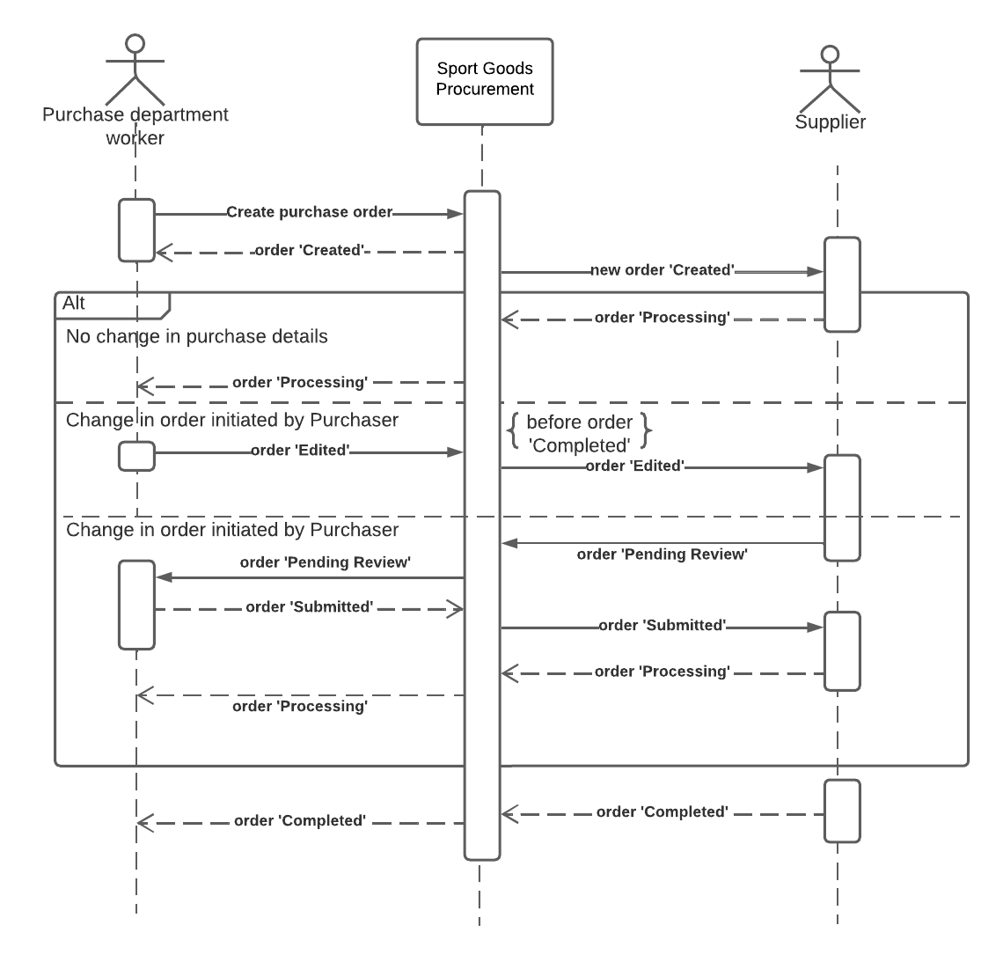

Image 1 - Order Flow Sequence Diagram UML

### Platform Data Concept

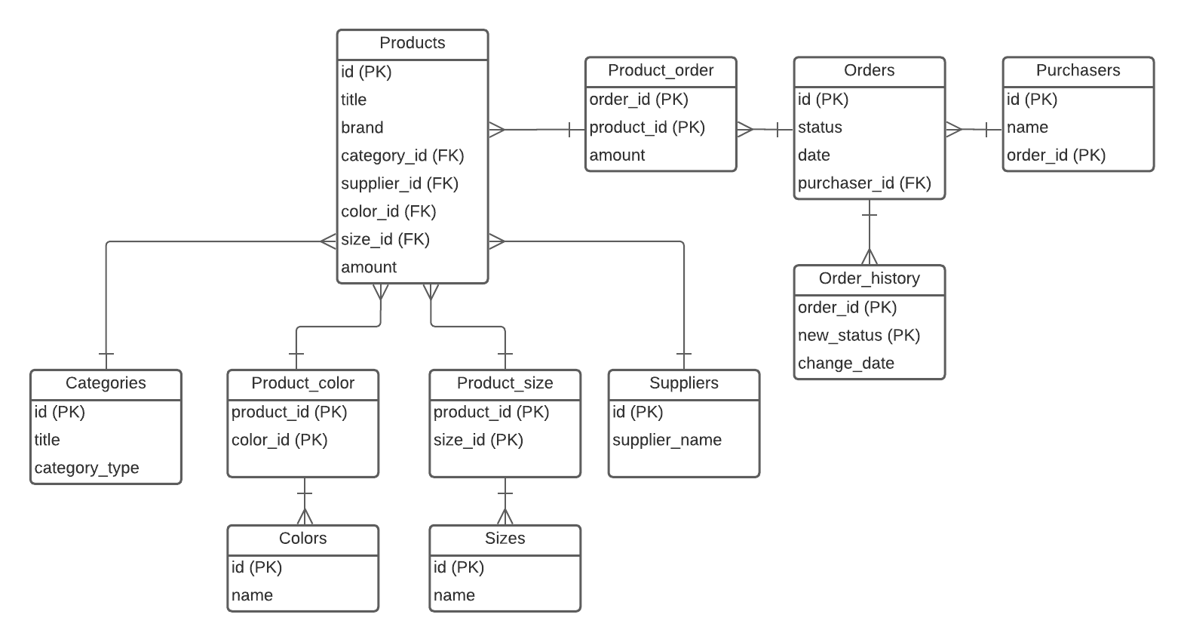

Image 2 - ER diagram

### UI Requirements

UIR1 - Platform should be implemented in the corporate colors

UIR2 - The clickable text objects should be underlined

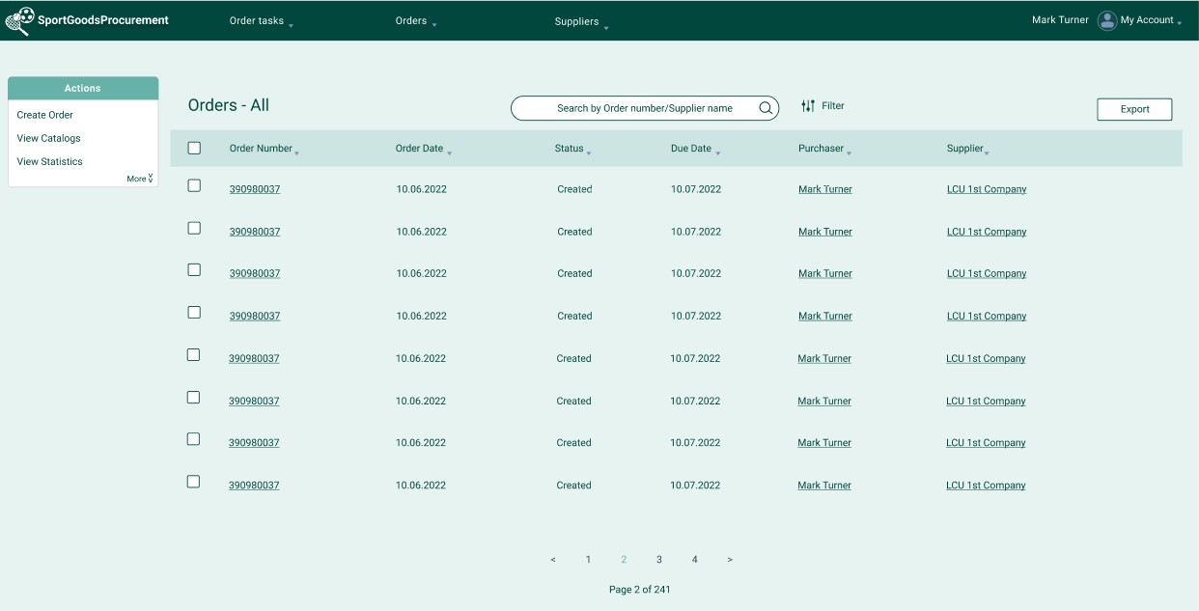

Image 3 - UI example (Purchase Department worker view) <https://www.figma.com/file/3Ry1FDijmOMk7EtPxx8LY7/Work-Sheet?node-id=0%3A1>